**Market Segmentation Analysis of EV market in India**

**Prepared By:** Sneha Tanaji Shinde  
**Dataset Used:** Indian Automobile Buying Behaviour Study 1.0  
**Focus:** Clustering by total_salary to uncover insights for launching a successful EV startup in India.

## Objective

To apply unsupervised machine learning techniques to segment customers based on their total income (total_salary), analyze electric vehicle purchase trends, and develop region-specific business strategies aligned with current EV market conditions and future growth potential.

## Tools, Libraries, and Models Used

* **Python Libraries:** pandas, matplotlib, seaborn, scikit-learn
* **ML Models:**

KMeans Clustering for segmentation

Elbow Method to select optimal clusters

* **Supportive Visualizations:**

Scatterplots, Boxplots, Countplots

* **EDA:**

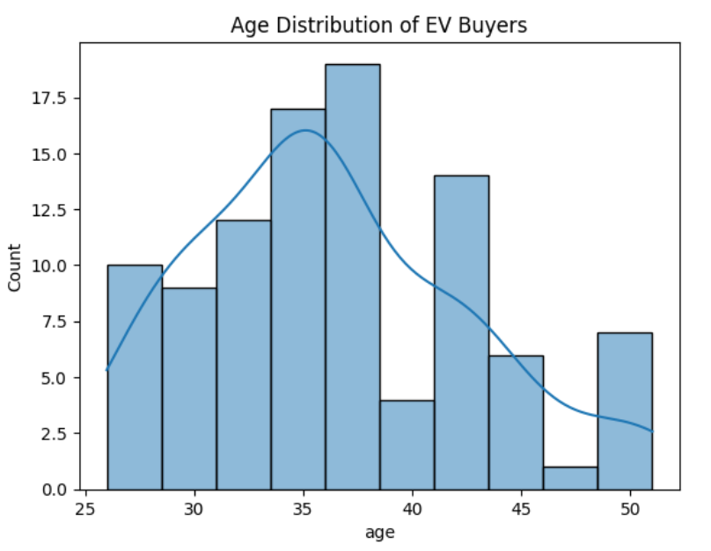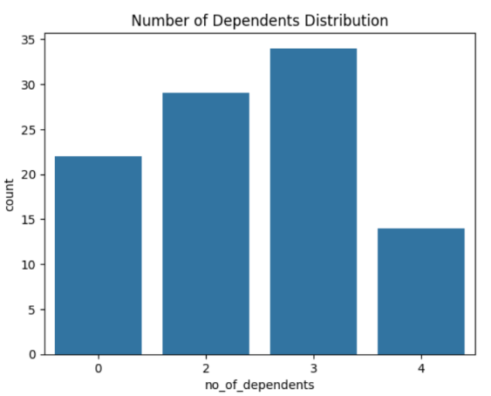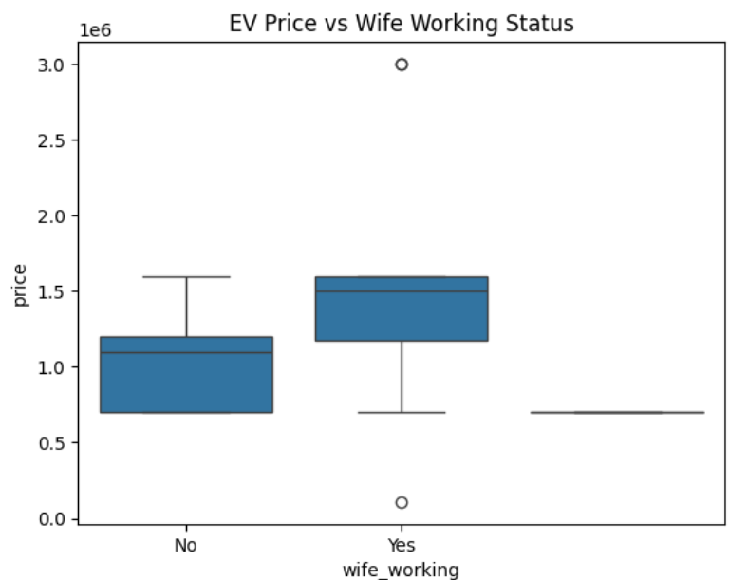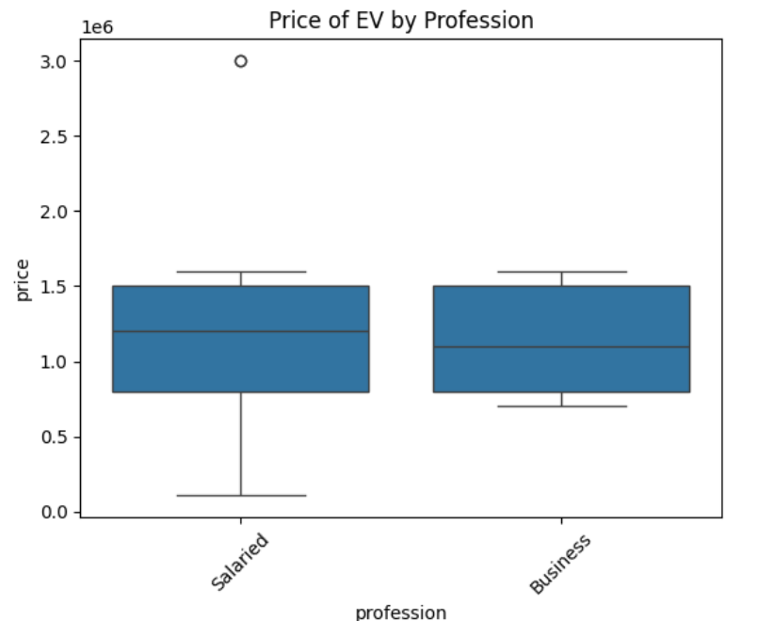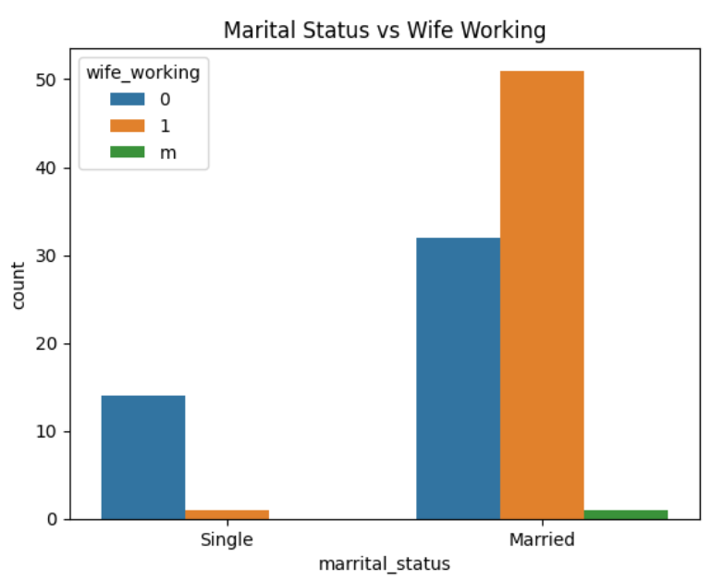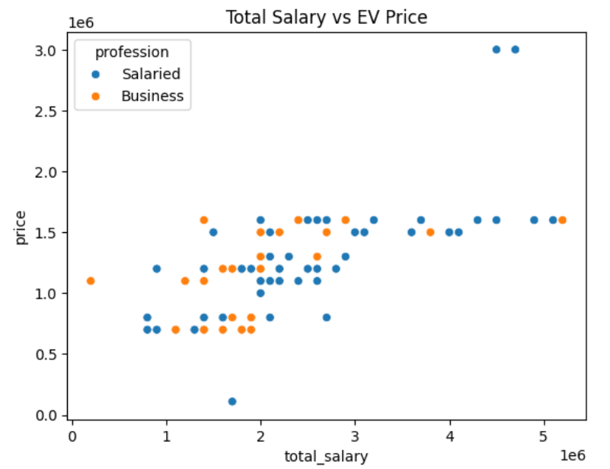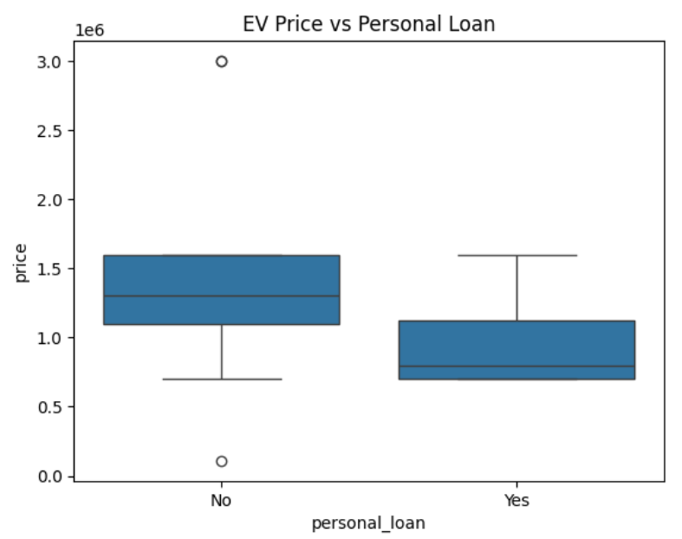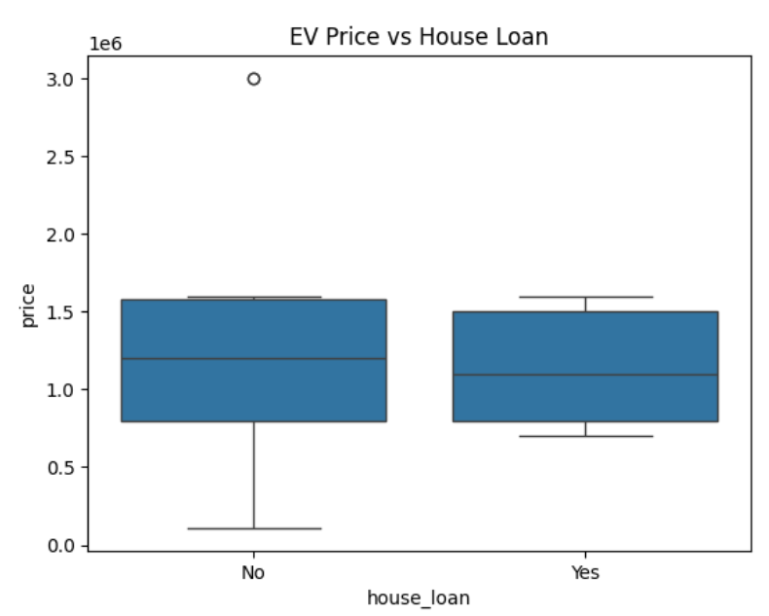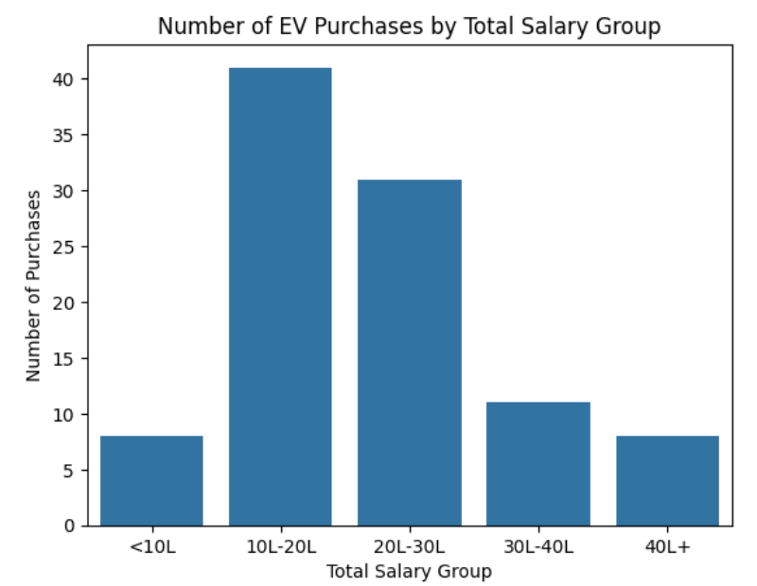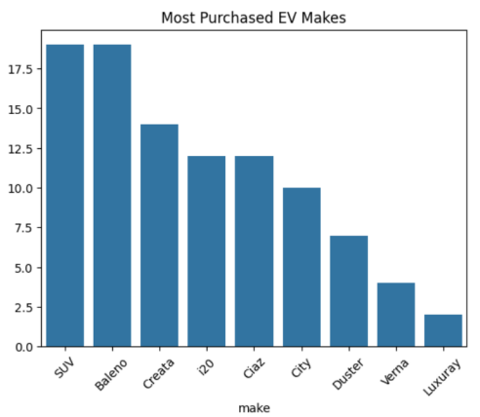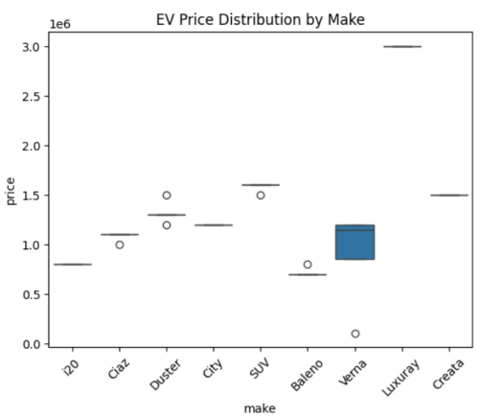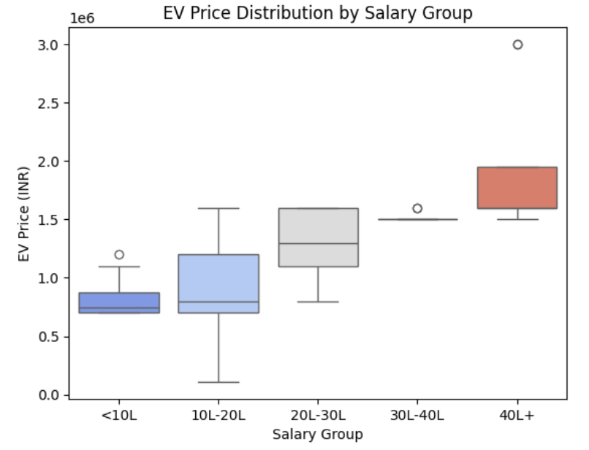

**Screenshot 2025-04-14 174345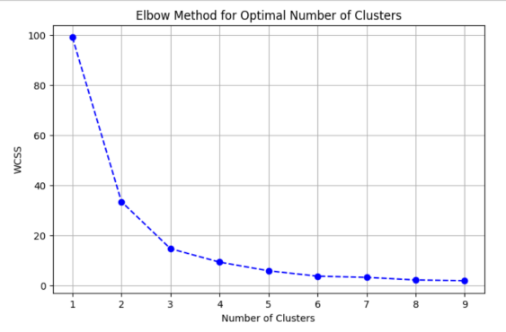Screenshot 2025-04-14 174431**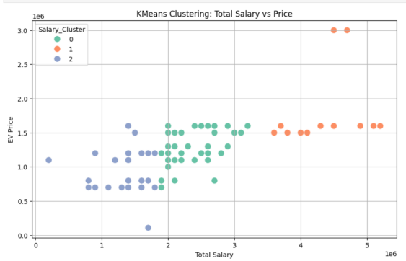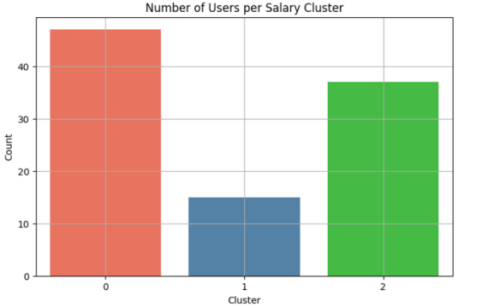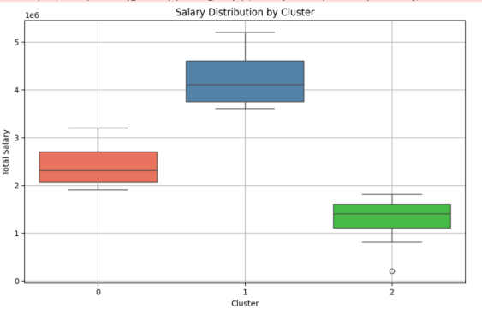

## Why Focus on Total Salary?

- Total salary gives a realistic measure of a household's purchasing power. Unlike individual salary, it includes spouse income, reflecting actual affordability:

* Helps identify premium vs. budget buyer segments
* Influences vehicle type preference (sedan/SUV)
* Affects eligibility for loans or EMI

## Process Overview

### 1. Data Preparation

* Selected the total_salary feature
* Standardized the variable for KMeans clustering

### 2. Elbow Method

* Plotted WCSS for k=1 to k=10
* Found the optimal k = 3 (the elbow point)

### 3. Clustering Execution

* Applied KMeans with n_clusters=3
* Assigned cluster labels to dataset

## Visualization & Insights

### Cluster 0: Budget Buyers

* Low total salary (< ₹10L)
* Small EV price range (₹8–12L)
* Recommendation: Small city EVs, EMI options

### Cluster 1: Mid-Tier Buyers (Largest Group)

* Salary between ₹10–30L
* Comfortable purchasing mid-range EVs
* Target: Affordable SUV/hatchback EVs with 300+ km range

### Cluster 2: Premium Buyers

* ₹30L+ income
* Preference for high-end features, fast charging, and brand
* Strategy: Luxury EVs with connected features

## Visualizations Summary

**Scatter Plot:** Salary vs EV Price shows clear cluster separation

**Box Plot:** Highlights salary distribution per segment

**Countplot:** Cluster 1 has the largest population → major market share

## Alignment with National EV Market Trends

According to national data , the Indian EV market is:

* Estimated at ₹6 lakh crore ($72B)
* Projected to reach ₹50 lakh crore by 2030
* Driven by states like Karnataka, Gujarat, Maharashtra, Tamil Nadu

Our segmentation aligns with macro insights:

* Middle-class (Cluster 1) drives growth
* Budget group (Cluster 0) needs financial incentives
* Premium segment (Cluster 2) is small but high-margin

## Business Idea Based on Clustering

### Strategy: Launch a Tiered EV Lineup

**Model A (Cluster 0):** Compact EV < ₹10L with EMI support

**Model B (Cluster 1):** Smart EV SUV (₹12–18L), efficient battery

**Model C (Cluster 2):** Premium electric sedan (₹25L+), tech-loaded

### Market Entry Plan

**Primary Launch State:** Karnataka (esp. Bengaluru) → tech-savvy + infrastructure

**Secondary Entry:** Gujarat (Morbi) → growing demand, less saturated

## Final Business Recommendations

* Prioritize Cluster 1 – the heart of the Indian EV consumer market
* Create offerings for Clusters 0 & 2 to expand base
* Invest in charging stations in high-cluster density cities
* Use AI-powered segmentation tools for continuous market monitoring

## ✅ Final Conclusion

## The KMeans clustering based on total salary revealed three distinct consumer personas crucial to shaping an EV strategy. Aligning this with national EV market data shows:

* **Cluster 1 is the sweet spot for volume-based success**
* **Premium growth is possible with differentiation and tech**
* **Budget buyers can be onboarded with EMI + subsidies**
* Data-driven market segmentation is essential for the success of any new EV venture in India.

With the right tiered strategy, location targeting, and continued model refinement, a new EV brand can thrive in this rapidly growing market.

Github link- [https://github.com/SnehaShinde08/Market-Segmentation-Analysis-of-EV-market-in-India]